SpecterX Future Versions Log — Policy Assignment Rules V2+

Future Version Record Notes
- Last Idea Added: 2026 Feb. 21st
- Last Strategic Review (CTO / Product): YYYY-MM-DD
- Current Product Record Reference: [PAR V1 Product Record]
- Current Platform Version Reference: Release V1.19.

Identified for Next Version (V2)
Items in this section are placed by the product team after review of logs or after development concludes with known next version items.

Tenants without Purview Integration Setup is messaged in Rule Configuration Console
- Status of integration with Purview within the Admin configuration console is not clearly messaged, showing consistent UI presentation regardless of integration status:
  - “Sensitivity labels are synced from your organization’s Microsoft Purview configuration. Leave empty to apply regardless of file sensitivity. Selecting a label restricts the rule to files with that label.”
- The goal of V2 is for UI to show varied text based on integration sync status.
  - If not yet integrated:
    - “No sensitivity labels available. Integrate your organization’s Microsoft Purview instance to enable label-based rules.”

Share Drawer Integrated for Permission Modification Flows in WebUI
- New Share Drawer will be adapted to replace existing file permission modification flows for a unified PAR experience in the WebUI.
- UI replacements & designs are mapped for implementation here.
- Tickets for Feature improvements linked here.

Block Results Presentation is Updated for Better Summary - Ticket 5527
- In V1, Blocked result presentation is split
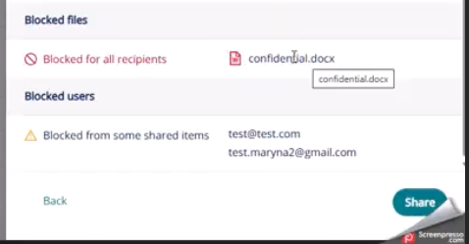

- In V2 these will be combined into one section that shows all block results.
- Below is one proposed design but revision is needed to resolve duplication.

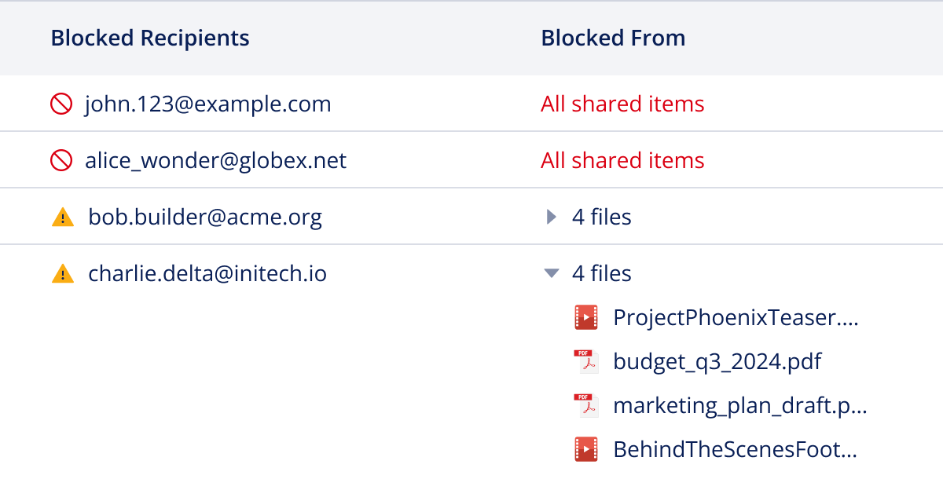

Provide Linked Pane for Editing of Missing Details for Existing Recipients
- In V1, presentation of Missing Details appears in Pane 2 states with Policy and when multiple recipients are listed this becomes a very crowded view. If policy changes, missing details could also be required for existing recipients and we must also provide the ability for the sender to update recipient details here too.
- To address this, we are suggesting a linked Pane to edit all provisioned recipient details as shown in Mocks below.
- Only recipients with missing detail will be shown in the core presentation of Pane 2 and the full list of recipients can be viewed via the link to edit their details.

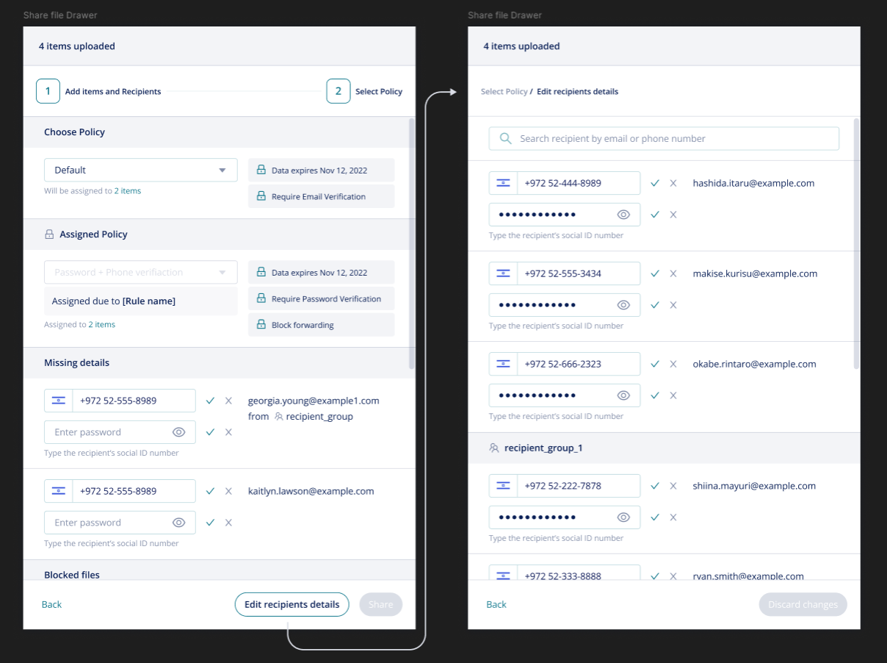

File Upload will Independently Trigger PAR evaluation
- Today, the ability to upload files without recipients can only occur as a result of an incomplete share. If share is abandoned without policy assignment, the tenant default is applied which presents behavior unexpected based on PAR rules which can dictate policy assignment based solely on file label
  - Without enforcing evaluation solely on file upload, we have created scenario that will present failed file block events

PAR Model expanded to full ecosystem
- PAR will introduce source or share context for decision, assigning a policy or making exceptions based on channel origin
  - For example, applying Domain Forwarding policy to all reports exported from Salesforce to support exceptions or assignment rules based
- PAR model will be adapted for Channel (implicit recipient list) Connectors like Slack, Teams and Workspaces. This implicit recipient list was outlined to operate much like group membership:
  - If one recipient of the channel or Workspace is blocked from the file, the file can’t be added. This would likely need to override exception logic - or clear distinction made.

PAR will Treat Folders as a distinct object
- In V1 folders are supported in the PAR model in non-explicit way - the files within the folders are evaluated and actioned by PAR, but PAR does not explicitly address folder policy assignment.
  - In PAR new share drawer flows, PAR recognizes the folder container as an additional item of an upload that requires policy assignment – a folder upload containing 4 files is viewed by PAR as a 5 item upload, where PAR might apply policy to the 4 files and then require the user to assign policy to the remaining item which is the folder itself. Why this workflow works and does support the logic of our platform, it isn’t clearly messaged to the user in initial Share Drawer Flows.
- A by-product of this V1 approach also creates odd behavior when policy assignment is required between one party and another, but PAR can’t enforce it at the folder level.
  - For example, if a rule is in place that requires AIP policy for all external sharing and a folder is shared externally, PAR will request that the user selects a policy for the folder container but all files within it will be overridden with an AIP policy.

- Future versions of folders handling may address this with PAR governance moving to the container level and this should be done to align with logic of Workspaces OR at very least, consideration for their overlap.

Identified but Unslated

Policies in Active Rules cannot be Deleted
- Controls will be implemented to the Policy Configuration to prevent admins from deleting policies of active rules. (flagging here and policy configurator future versions record)

Implement Audit Logs for Admin Rule Configuration & Testing
- Actions taken by admins that affect governance are audited:
  - Published state changes
  - Testing of rules
- Scoped in this PRD record

Editing, Saving & Testing Rules
- Draft state of the entire reset will be introduced - removing the ability to edit the active ruleset
- Draft rulesets will show valid vs invalid inputs to condition field
- Autosaving of draft changes may be implemented
- Implement controls to allow concurrent editing of rules by Admins
- Testing of Rulesets will be enabled on both inactive and draft rulesets

New Share Drawer Collaborator UI Changes
- New Share Drawer will move encrypted message and auto delivery as a post access provision step in Pane 4 rather than pre-share decision in Pane 1

Example Rules Present in Welcome State of Configuration Module
- Example rules will be created in draft state to give reference as a starting point for rule creation
- Example rules should align with sample policies created for new tenants

Expand Auditing Visibility for Admins to allow for Visibility into Rule Triggers
- Admin visibility of system actions will expand beyond the existing framework of current audit logs, allowing more context to be added for easier reasoning comprehension
- This development will coincide with migration and overhaul of admin audit logs to the admin portal

Expand Alerting for Admin Subscription to PAR Alert Types
- User level actions
- Admin level actions

Allow PAR to Act Upon Protection of Email Body
- To support current functionality offered in pre-existing transport rules
- Aligning with source channel rule specification

Clarification (Loren asking):
- Could this also be an expansion within Purview to read labels applied to the email body?

Support Blocking and Quarantining Emails
- V1 PAR does not allow emails themselves to be blocked from sending, even if all attachments may be blocked
- Allowing blocking of email should be introduced with the ability to quarantine emails for a mature solution for less potential user and admin friction – and meet market expectations for similar product functions

Expand Integration and Intelligence with DLP
*This expansion is feeds key strategic direction for SpecterX
- As the central platform governance engine, PAR provides a future path for deeper DLP integration, supporting possible paths to:
  - Suggest policy based on file classification rather than Label
  - Call DLP for file classification and act upon file state changes
  - Act upon quarantined files from DLP

Expansion of PAR to Govern AI Data Use
*This expansion is feeds key strategic direction for SpecterX

- As governance territory expands to AI platforms PAR Governance must also expand with it.
- This is future version state is unplanned but flagged to pull into the central governance logic of the platform in full

Rule Conditions by File Size, Type & Name
- Moved out of V1 plans due to complexity

Re-evaluation of Rule with Ownership Transfer
- Ownership transfer is not a trigger for PAR evaluation in V1 but considered for future versions

Pre-population of Sample Rules
- Implement sample rules in the Admin configuration welcome state as demonstrative draft rules that are inactive and can be deleted.

Revision of V1 Mail Notifications
The V1 template model will expand to include all listed recipients and/or files affected by backend action. This does present an edge case of very long lists populating within notifications which will be addressed in V2 through action summarizations.

